Section2

Aws:setup(IAM)

(Steps in book)

Section3 ;VMs

Chapter1:Ssh connection between vmware and windows through gitbash

In centos terminal

1)ip addr show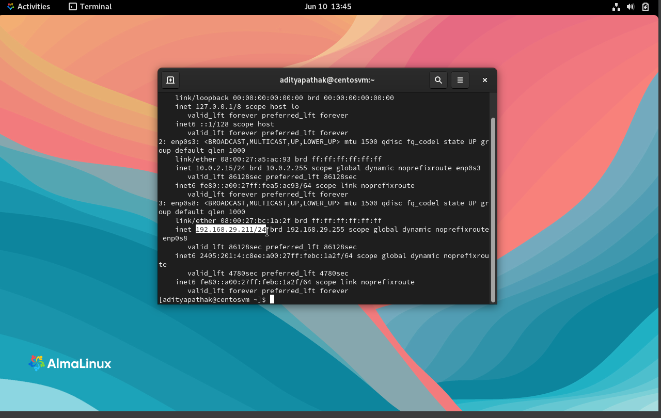

2.take the note of the ip address your are seeing and the username

3.now open gitbash

Type the username@ipaddress

[adityapathak@192.168.29.211](mailto:adityapathak@192.168.29.211)

chapter 2:vagrant

1)create a directory where you want to create vagrant vm on your windows device

And make 2 folders

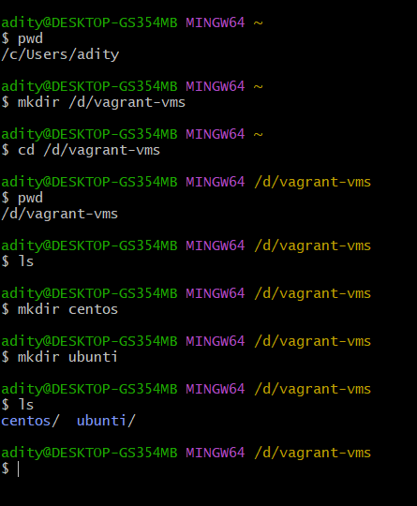

2.go to cento directory and go to vagrant cloud

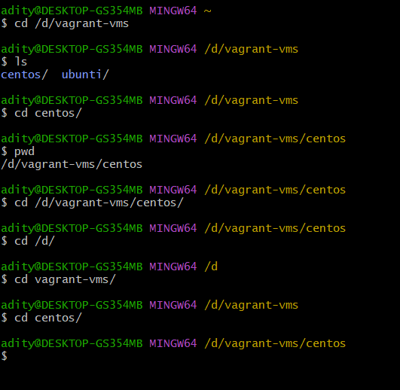

3.in vagrant cloud on web

Search centos9

Select’eurolinux vagrant’

Copy the highlighted text from the image below

Paste it in git(shoft+insert)

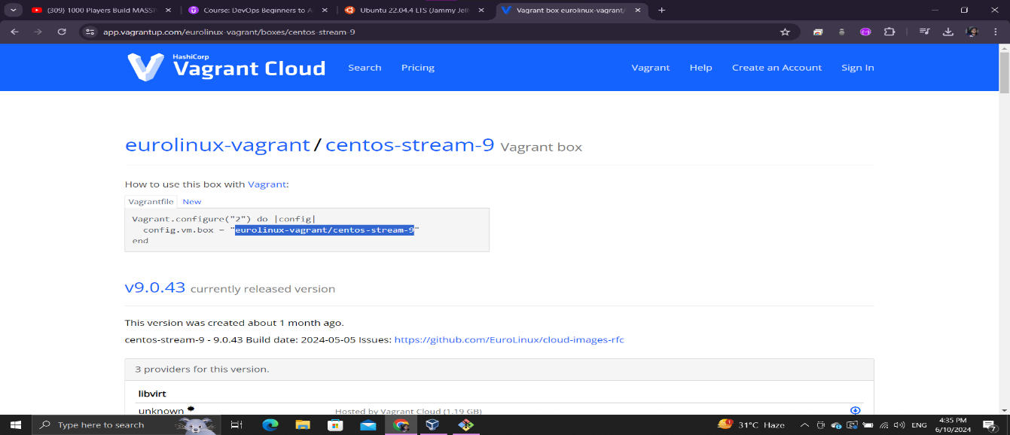

4)cat is used to read the file content

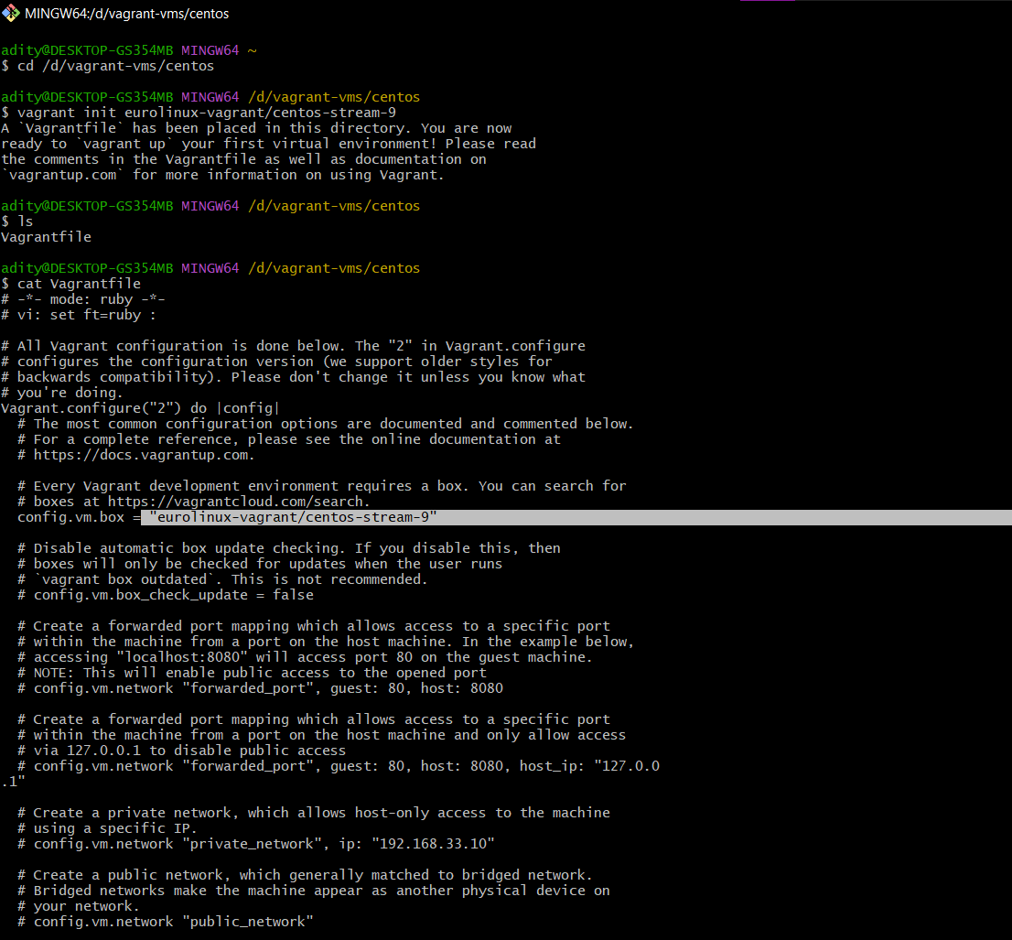

5)vagrant up to turn on the vagrant vm

Vagrant box list-content list

Vagrant ssh

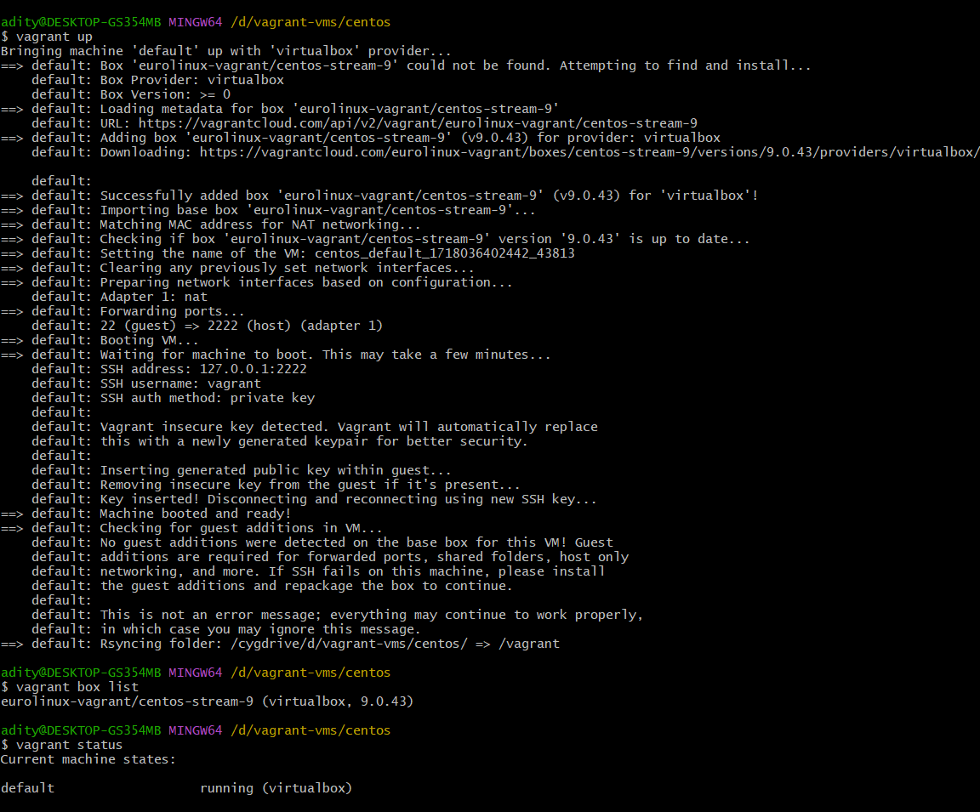

6)vagrant ssh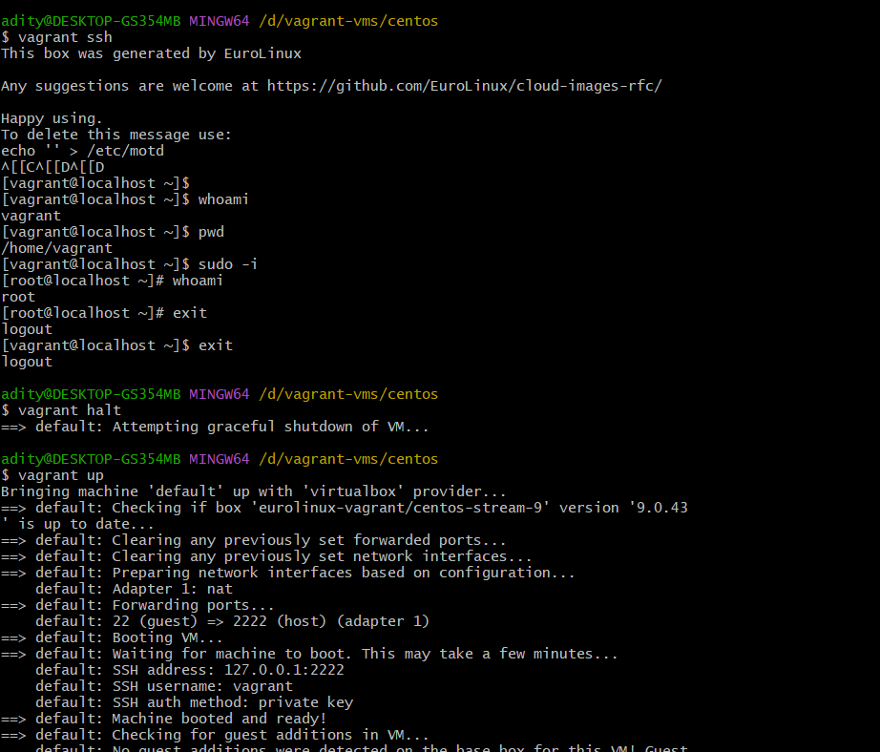

7)vagrant for ubuntu

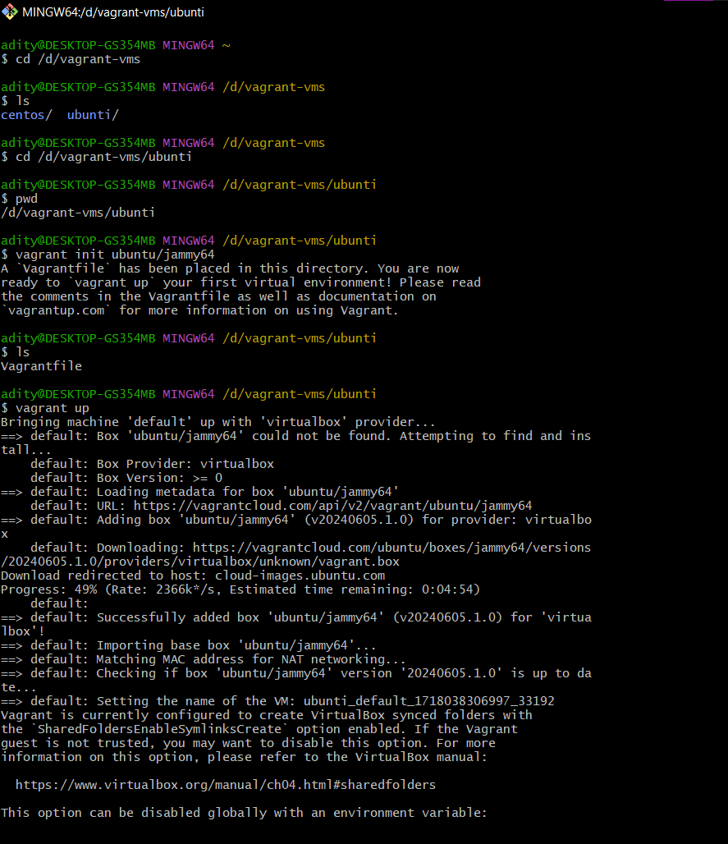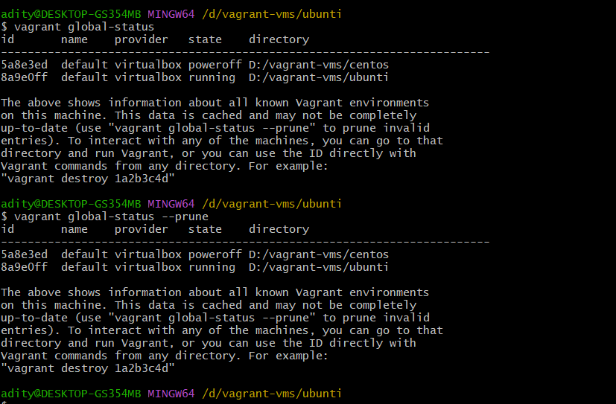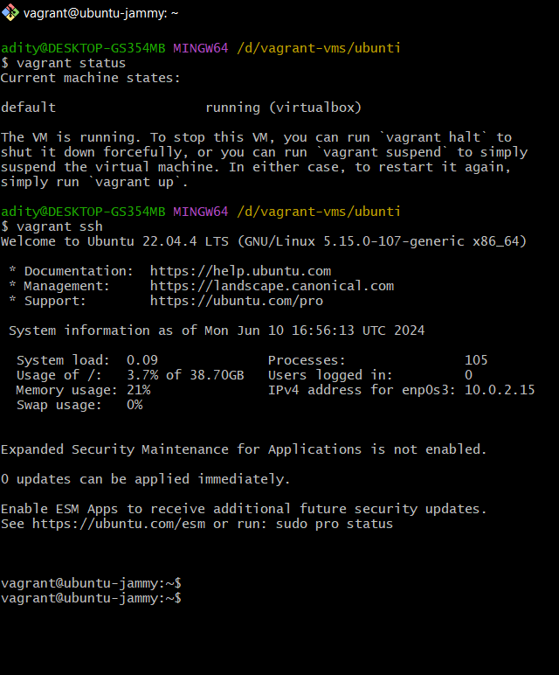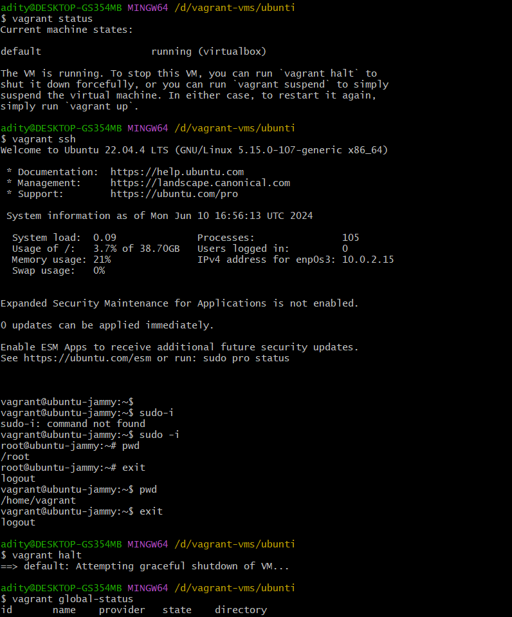

8)history command for all the commands you have executed